**PREDICTION FOR UNIVERSITY ADMISSION USING MACHINE LEARNING**

Developed by: **Bajjuri Anuhya, Bourishetty Swetha, Vijayagiri SaiHarsha , Junnuthula Akshaya**

**Smart Bridge - Remote Summer Internship Program**

Abstract:

In today's education world there are many number of students who want to pursue higher education after engineering or any graduate degree course. We are focusing on only the students who want to pursue their higher education in abroad universities. Generally Higher education in abroad universities means we have many options like Canada, USA ,UK Germany, Italy, Australia etc. But we are focusing on only the students who want to do their Masters in America. Here comes the problem that the student don’t know to which university he might get admission. There are some online blogs which help in these matter but they are not that much accurate and don’t consider all the factors and there are some consultancy offices which will take lot of our money and time and sometimes they will give some false information . So our goal is to develop a model which will tell the students their chance of admission into a respective university. This model should consider all the crucial factors which plays a vital role in student admission process and should have high accuracy.

Introduction:

* Specific preparation plays a crucial part in your life. Thus education preparation students often have multiple questions about universities which they can get admission and scholarship and accommodation. One of the main concerns is getting admitted to their dream university .It's seen that students still choose to obtain their education from universities that are known internationally.
* when it comes to international graduates, the United States of America is the first preference of the majority of students.
* With most world-renowned colleges, Wide variety of courses available in each discipline, highly accredited education and teaching programs, student scholarships, are available for international students.
* The number of people pursuing higher studies in different countries are rapidly increasing. The background reason for the students going to abroad universities for Masters is the no. of job opportunities present are low and number of people for those jobs are very high in their respective countries . This inspires many students in their profession to pursue postgraduate studies.
* It is seen that there is quite a large number of students from universities in the USA pursuing Masters in the field of computer science, the emphasis of this research will be on these students.
* Many colleges in the U.S. follow similar requirements for student admission. Colleges take different factors into account, such as the ranking on aptitude assessment and academic record review. The command over the English language is calculated on the basis of their performance in the English skills test, such as TOEFL and IELTS. The admission committee of universities takes the decision to approve or reject a specific candidate on the basis of the overall profile of the applicant application.

METHODOLOGY

* **Problem Understanding:** Initially first we have to spend some time on what are the problems or concerns students having during their pre admission period and we should set the solutions to those problems as objectives of this research.
* **Data Understanding:** Data should be collected from multiple sources and also consider all the factors including which will play a tiny role in student admission process.
* **Data Preparation:** Data should be cleaned that is removing the noise in the data and filling the missing values or extreme values and finalising the attributes/factors which will have crucial importance in student admission process.
* **Building Models:** several ML models have to be developed using various machine learning algorithms for admission to a particular university and the user interface has to be developed to access those models.
* **Evaluation:** Developed models are evaluated according to their accuracy scores. Once the model is finalised that model will be merged with node red for final deployment.

Purpose:

* 400 applicants have been surveyed as potential students for UCLA. The university weighs certain aspects of a student’s education to determine their acceptance.
* Our dataset consists of University Dataset for determining university decision

401 rows with 9 columns:

GRE score ,TOEFL score, University rating, SOP, LOR, CGPA, Research, Chance of admit.

Data source: Internet

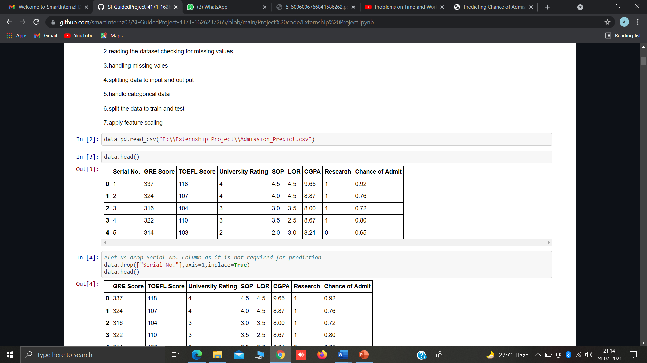

* The objective is to explore what kind of data is provided, determine the most important factors that contribute to a student’s chance of admission and select the most accurate model to predict the probability of admission.
* This project addresses machine learning models to predict the chance of a student to be admitted to a University. This will assist students to know in advance if they have a chance to get accepted. The machine learning models are multiple linear regression, logistic regression, k-nearest neighbour, random forest, and Multilayer Perceptron. Experiments show that the Logistic Regression model surpasses other models.

LITERATURE SURVEY

**Existing methods that can be applied on Dataset:**

There are several Machine learning algorithms to be used depending on the data you are going to process such as images, sound, text, and numerical values. The algorithms that you can choose according to the objective that you might have it may be Classification algorithms are Regression algorithms.

Example:

1.Linear Regression

2.Logistic Regression

3. Random Forest Regression / Classification.

4. Decision Tree Regression / Classification.

You will need to train the datasets to run smoothly and see an incremental improvement in the prediction rate.

**On our Dataset, we have applied Logistic, Multilinear Regression and Random Forest , to predict the Accuracy.**

Proposed Solution:

Machine Learning ( Logistic Regression)

The previous models have less accuracy and the predictions are not at accurate whereas this model is constrained with the lot of advantages and with higher accuracy than any other model already proposed. In this model we used Machine Learning algorithm named Logistic Regression which give an accuracy 90% of accuracy for the predicted problem and there is an user friendly user interface to check whether a student will get admitted or not!

* Logistic regression is **a supervised learning classification algorithm used to predict the probability of a target variable**. The nature of target or dependent variable is dichotomous, which means there would be only two possible classes. ... Mathematically, a logistic regression model predicts P(Y=1) as a function of X.
* Logistic Regression is used when the dependent variable (target) is categorical. For example,
* To predict whether an email is a spam (1) or (0)
* Whether the tumor is malignant (1) or not (0)
* Out of all the algorithms Logistic Regression got the highest accuracy  .
* So, We build a model with Logistic regression.

THEORITICAL ANALYSIS

**Block diagram:**

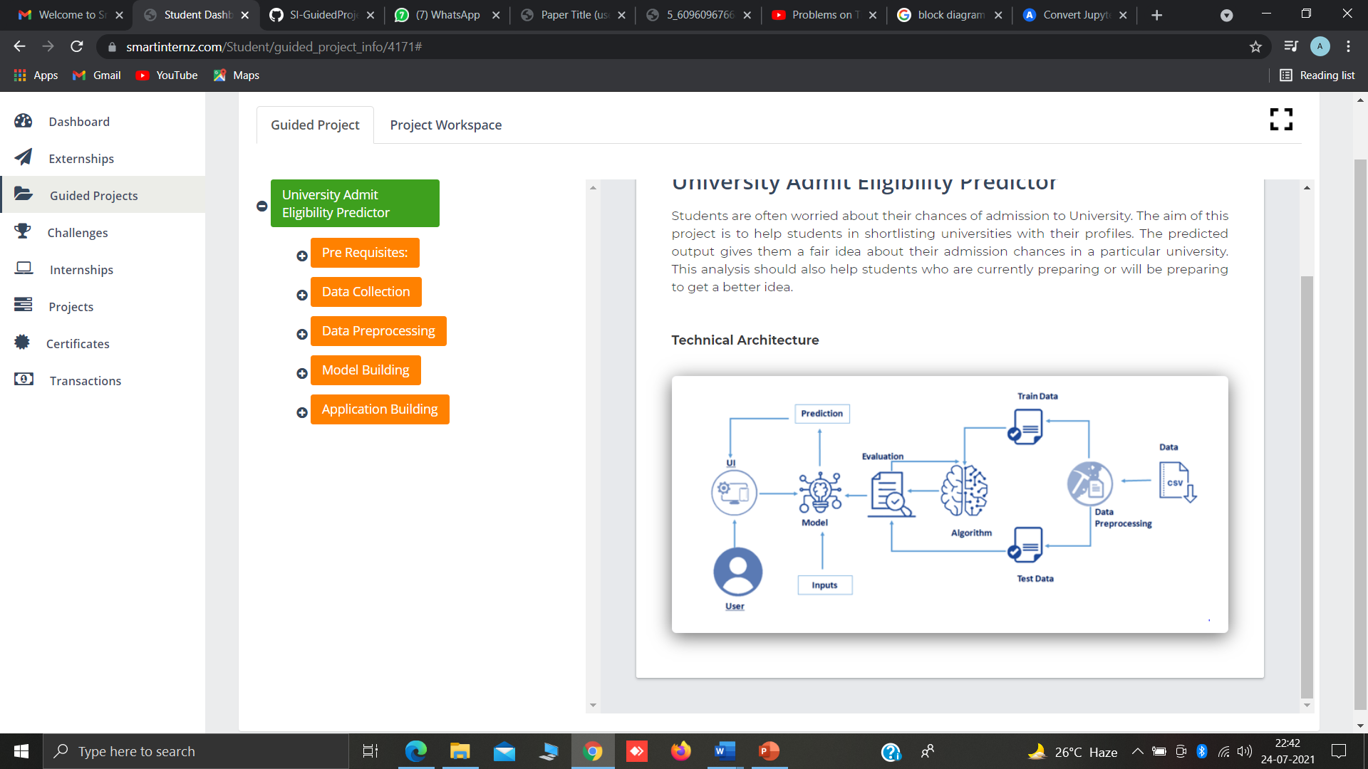

**Hardware / Software designing:**

* Google colab
* Anaconda navigator
* Jupyter notebook
* Machine learning tools: pandas,

numpy,

matplotlib,

scikitlearn, seaborn.

FLOWCHART

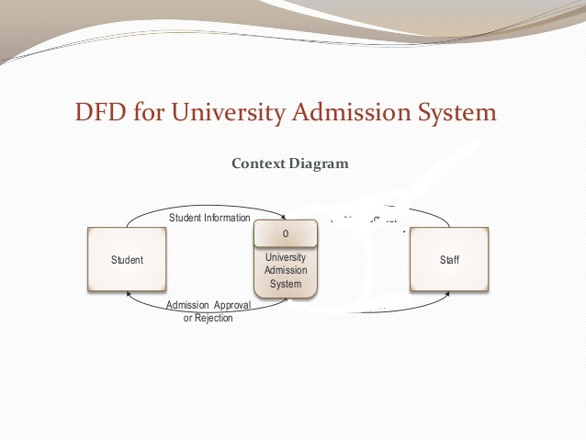

RESULT

**Results of regressions implemented:**

**Logistic Regression:**

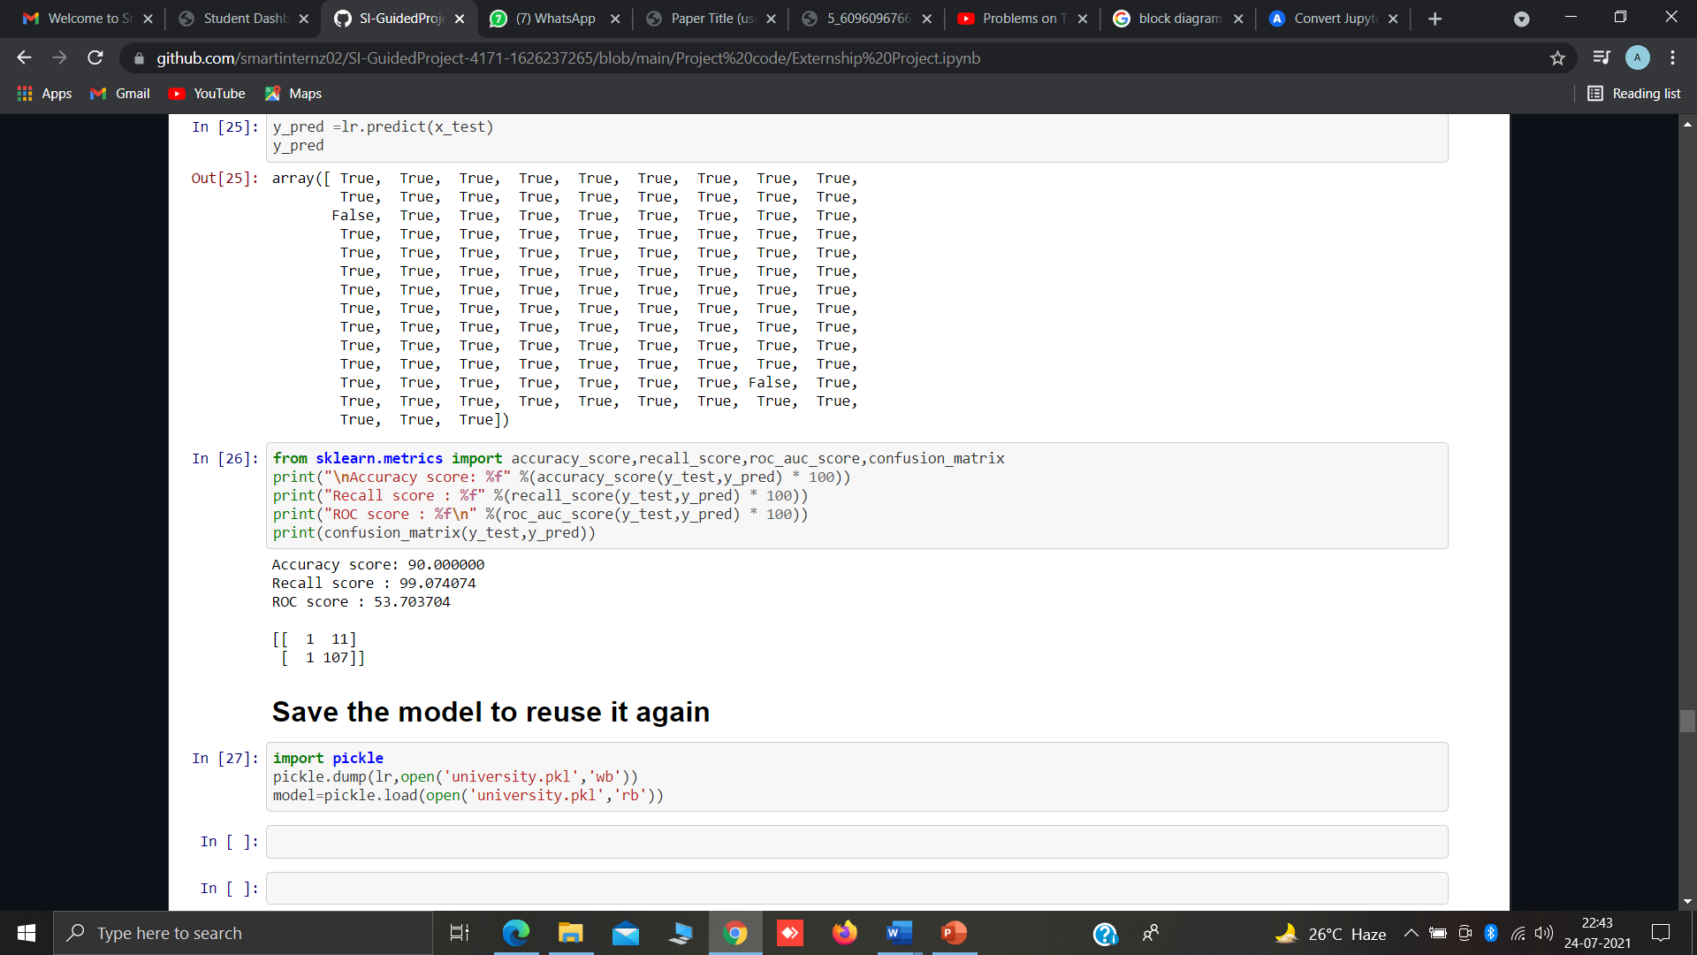

**Multilinear Regression:**

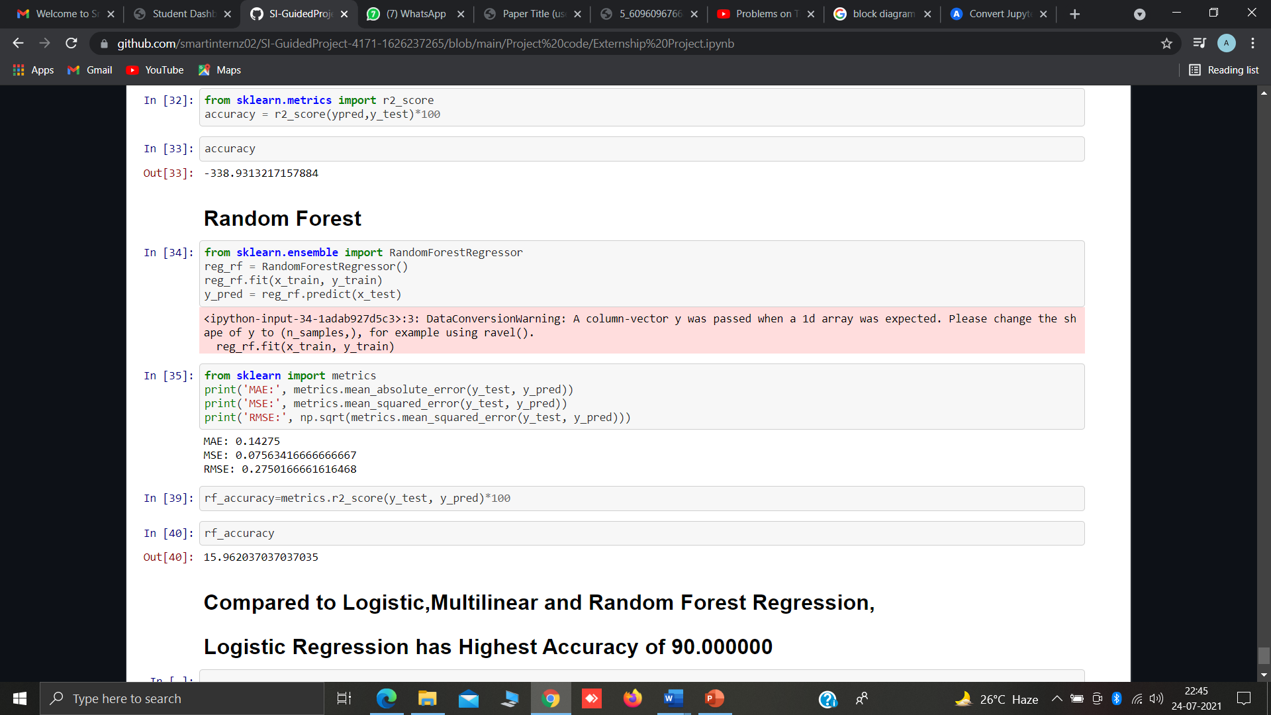**Results after Implementing the Flask:(Python code and Html Code):**

**Homepage for Prediction:**

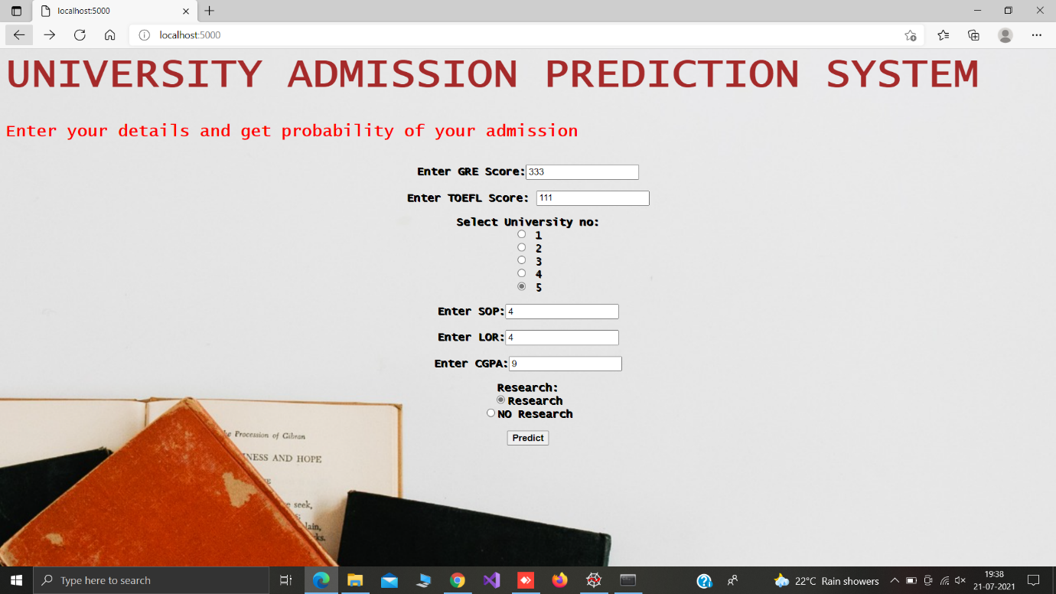

**Chance of Admission**

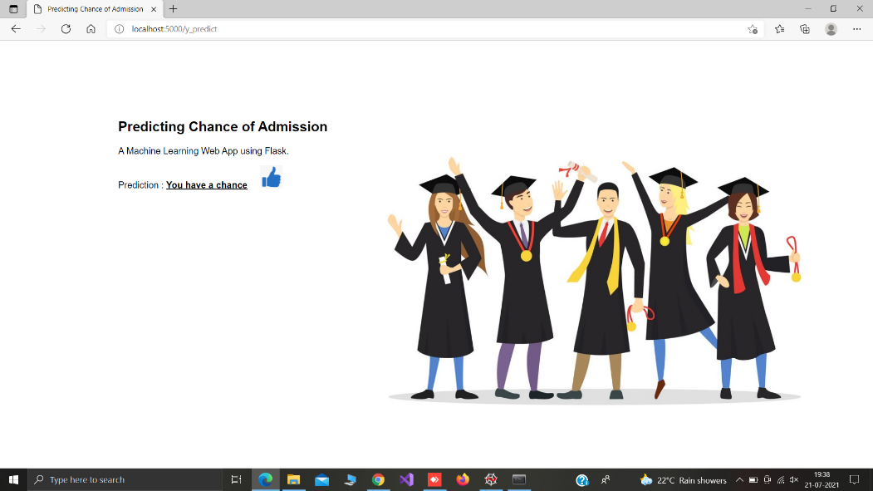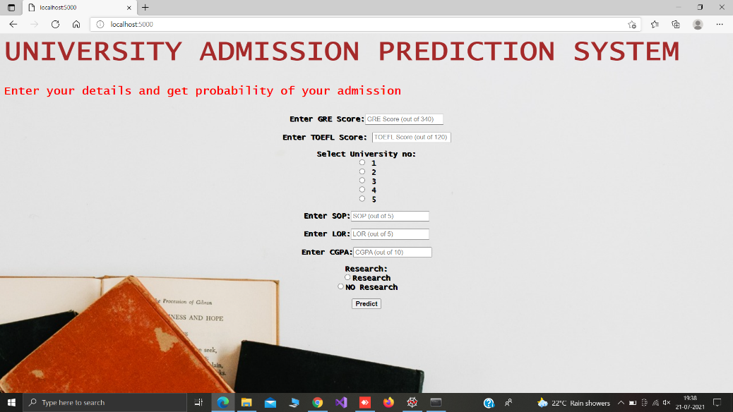

**noChance of Admission:**

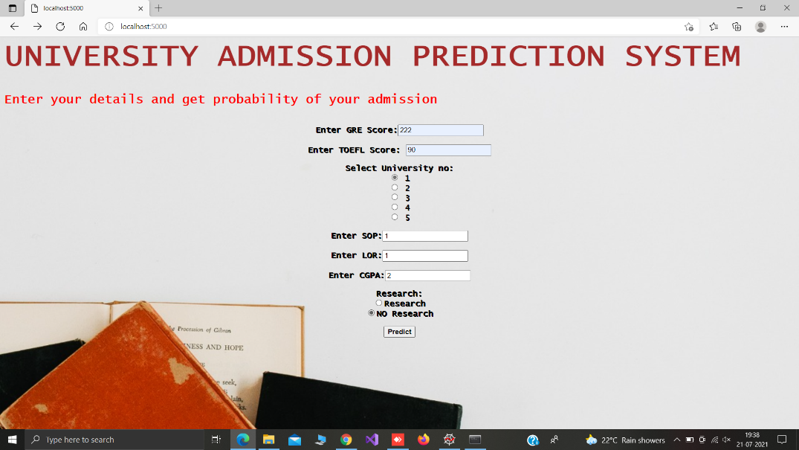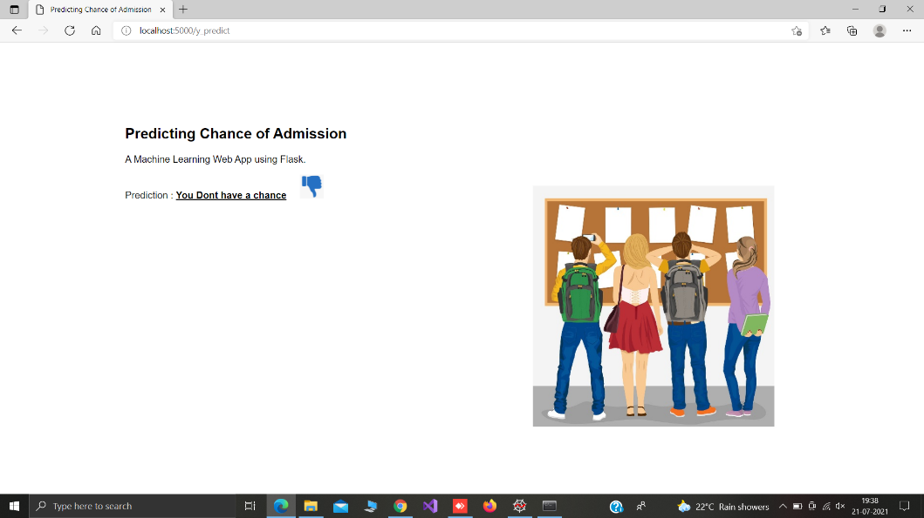

APPLICATIONS

● Predicting of a University Admission definitely help an individual seeking for a Admission in the Universities.

● This model is mostly used for Students who wants to get the admission in Universities with the help of their GRE Score , TOEFL Score , University Rating , SOP , LOR ,CGPA , Research.

● Student will get to know whether he /she has the chance to get admitted or not.

● So we use Machine Learning Algorithms to predict the accuracy of our model .

ADVANTAGES AND DISADVANTAGES

**Advantages:**

● Effective predictive model which predicts whether student has a chance of Admission or not.

● Reduces the time consumption for Students

. ● Easy and simple User Interface for the Student’s who wants to get to know about their admission.

● Logistic Regression is simple to implement and easy to interprete the output.

● Logistic Regression gave the accurate result of the prediction upto 90% which is the algorithm we used for prediction.

● It is composed using the HTML and Python for the web usage in real time

. ● It can work in real time and predicted as soon as the necessary details for prediction are given to the model.

**Disadvantages:**

●The model should be highly predictive in nature i.e it should show 80% of accuracy.

●The model should give high accuracy when tested it on the test dataset.

CONCLUSION

In this project, Machine Learning models were performed to predict the opportunity of a student to get admitted to a University. The Machine Learning models included are multiple Linear Regression, Logistic regression, Random forest. Experiments show that the Logistic Regression model surpasses other models.

FUTURE SCOPE

In future, more data related to additional universities and courses can be added to the system. Also, the system can be enhanced to a web-based application by making changes to the code. Other classification algorithms can be evaluated to resolve the problem if they perform better than the current algorithm the system can be easily updated to support the new algorithm by changing the server code . As for the future work, more models can be conducted on more datasets to learn the model that gives the best performance.

Bibiliography

Abdul Fatah S; M, A. H. (2012). Hybrid Recommender System for Predicting College Admission, pp. 107–113. Bibodi, J., Vadodaria, A., Rawat, A. and Patel, J. (n.d.). Admission Prediction System Using Machine Learning. Eberle, W., Simpson, E., Talbert, D., Roberts, L. and Pope, A. (n.d.).

Using Machine Learning and Predictive Modeling to Assess Admission Policies and Standards. Jamison, J. (2017). Applying Machine Learning to Predict Davidson College ’ s Admissions Yield, pp. 765–766. Mane, R. V. (2016). Predicting Student Admission decisions byAssociation Rule Mining with Pattern Growth Approach, pp. 202–207. MasterPortal (2017). MasterPortal. URL: http://www.mastersportal.eu/countries/82/united-states.html Mishra, S. and Sahoo, S. (2016).

A Quality Based AutomatedAdmission System for Educational Domain, pp. 221–223. Mozenda (n.d.). Mozenda. URL: https://www.mozenda.com/ Nandeshwar, A., Chaudhari, S., Sampath, V., Flagel, A., Figueroa, C., Sugrue, P., Ahlburg, D. and Mcpherson, M. (2014). Predicting Higher Education Enrollment in the United States : An Evaluation of Different Modeling Approaches, International Journal of Operational Research 19(26): 60–67. URL: http://ezproxy.bethel.edu/login?url=http://inderscience.metapress.com/content/fr20314q1862653k/%5Cnhttp://nandeshwar.info/wpcontent/uploads/2008/11/DMWVU Project.pdf Prescholar (2017). Yocket. URL: https://www.prepscholar.com/toefl/blog/toefl-to-ielts-conversion Thi, N., Hien, N. and Haddawy, P. (2007). A Decision Support System for Evaluating International Student Applications, pp. 1–6. Times, T. E. (2015).

The Economic Times. URL: https://economictimes.indiatimes.com/wealth/personal-financenews/around-3-lakh-indian-students-go-abroad-annually-33-take-property-backedloans/articleshow/48703656.cms?intenttarget=no Waters, A. and Miikkulainen, R. (2013). G RADE : Machine Learning Support for Graduate Admissions. Yocket (2017). Yocket. URL: https://yocket.in/

Appendix

**Homepage: Demo2.html**

<html>

<style>

body

{

background-image:url('../static/img/images1.jpg');

background-position: center;

font-family:"Lucida Console", "Courier New", monospace;

background-size:cover;

}

</style>

<body>

<div class="login">

<h1><b>UNIVERSITY ADMISSION PREDICTION SYSTEM</b><span class="label label-default"></span></h1>

<h2>Enter your details and get probability of your admission <span class="label label-default"></span></h2><br>

<style>

body {background-color: powderblue;}

h1 {color: brown;

font-size:60px;}

h2{color: red;}

p {color: red;}

form{text-shadow: 1px 1px;}

</style>

<form action="{{ url_for('y_predict')}}" method="post">

<center><b>Enter GRE Score:</b><input type="text" name="gre" placeholder="GRE Score (out of 340)" required="required"/><br><br>

<b>Enter TOEFL Score:</b> <input type="text" name="toefl" placeholder="TOEFL Score (out of 120)" required="required"/><br><br>

<b>Select University no:</b><br> <input type="radio" name="rating" value="1"> 1 <br>

<input type="radio" name="rating" value="2"> 2 <br>

<input type="radio" name="rating" value="3"> 3<br>

<input type="radio" name="rating" value="4"> 4 <br>

<input type="radio" name="rating" value="5"> 5 <br><br>

<b>Enter SOP:</b><input type="text" name="sop" placeholder="SOP (out of 5)" required="required"/><br><br>

<b>Enter LOR:</b><input type="text" name="lor" placeholder="LOR (out of 5)" required="required"/><br><br>

<b>Enter CGPA:</b><input type="text" name="cgpa" placeholder="CGPA (out of 10)" required="required"/><br><br>

<b>Research:</b><br> <input type="radio" name="research" value="1" ><b>Research</b><br>

<input type="radio" name="research" value="0"><b>NO Research</b> <br><br>

<button type="submit" class="btn btn-default"><b>Predict</b></button>

</center>

</form>

{{prediction_text}}

</div>

</body>

</html>

**Nextpage: chance.html**

<html lang="en" dir="ltr">

<head>

<meta charset="utf-8">

<title>Predicting Chance of Admission</title>

<link rel="shortcut icon" href="{{ url_for('static', filename='diabetes-favicon.ico') }}">

<link rel="stylesheet" type="text/css" href="{{ url_for('static', filename='styles.css') }}">

<script src="https://kit.fontawesome.com/5f3f547070.js" crossorigin="anonymous"></script>

<link href="https://fonts.googleapis.com/css2?family=Pacifico&display=swap" rel="stylesheet">

</head>

<style>

body

{

background-image:url('../static/img/chance.jpg');

background-position: center;

font-family:sans-serif;

background-size:cover;

}

</style>

<body>

</br></br></br></br></br></br>

<!-- Website Title -->

<div style="padding-left:200px">

<div class="container">

<h2 class='container-heading'><span class="heading_font">Predicting Chance of Admission</span></h2>

<div class='description'>

<p>A Machine Learning Web App using Flask.</p>

</div>

</div>

<!-- Result -->

<div class="results">

<p>Prediction : <b><u>{{prediction_text}}</u></b>&nbsp;&nbsp;&nbsp;&nbsp;&nbsp;<img src="../static/img/thumbs-up.png" width="40" height="40"></p>

</div>

</div>

</body>

</html>

**Nextpage: noChance.html**

<html lang="en" dir="ltr">

<head>

<meta charset="utf-8">

<title>Predicting Chance of Admission</title>

<link rel="shortcut icon" href="{{ url_for('static', filename='diabetes-favicon.ico') }}">

<link rel="stylesheet" type="text/css" href="{{ url_for('static', filename='styles.css') }}">

<script src="https://kit.fontawesome.com/5f3f547070.js" crossorigin="anonymous"></script>

<link href="https://fonts.googleapis.com/css2?family=Pacifico&display=swap" rel="stylesheet">

</head>

<style>

body

{

background-image:url('../static/img/noChance.jpg');

background-position: center;

font-family:sans-serif;

background-size:cover;

}

</style>

<body>

</br></br></br></br></br></br>

<!-- Website Title -->

<div style="padding-left:200px">

<div class="container">

<h2 class='container-heading'><span class="heading_font">Predicting Chance of Admission</span></h2>

<div class='description'>

<p>A Machine Learning Web App using Flask.</p>

</div>

</div>

<!-- Result -->

<div class="results">

<p>Prediction : <b><u>{{prediction_text}}</u></b>&nbsp;&nbsp;&nbsp;&nbsp;&nbsp;<img src="../static/img/thumbs-down.png" width="40" height="40"></p>

</div>

</div>

</body>

</html>

**Python Code: app.py**

import numpy as np

from flask import Flask, request, jsonify, render_template

import pickle

app = Flask(__name__)

model = pickle.load(open('university.pkl', 'rb'))

@app.route('/')

def home():

return render_template('Demo2.html')

@app.route('/y_predict',methods=['POST'])

def y_predict():

'''

For rendering results on HTML GUI

'''

#min max scaling

min1=[290.0, 92.0, 1.0, 1.0, 1.0, 6.8, 0.0]

max1=[340.0, 120.0, 5.0, 5.0, 5.0, 9.92, 1.0]

k= [float(x) for x in request.form.values()]

p=[]

for i in range(7):

l=(k[i]-min1[i])/(max1[i]-min1[i])

p.append(l)

prediction = model.predict([p])

print(prediction)

output=prediction[0]

if(output==False):

return render_template('noChance.html', prediction_text='You Dont have a chance')

else:

return render_template('chance.html', prediction_text='You have a chance')

if __name__ == "__main__":

app.run(debug=True)